Democratic backsliding in the United States – Handout

What is democracy?
Minimalist definition | Maximalist definition
Definition: Citizens are free to choose their government | Democracy is a method for realizing certain extrinsic values, like representation, accountability, justice, dignity
Democracy is a method for processing conflicts in a society
Problem: Certain decisions are hard to assess using minimalist criteria.  Example: Letting more people vote, because you know they vote for your party. | Problem: There are different “maximalist” definitions of democracy, because people value different ideals

Central Aspects
- Respect for human rights
- Multi-party political system
- Honesty and valuing of the truth
- Equal and respected voting system
- Respect for the rule of law
- Free courts
- Freedom of speech
What is democratic Backsliding?
Definition: State-led weakening or elimination of the political institution and conditions, that sustain an existing democracy
- Happens slowly and incrementally
- Often comes wrapped in legality
- Sign: Independent institutions, like courts start enabling governmental acts without question
- Often justified by one of these reasons:
- Fighting threats to national security or public order
- Checking rampant corruption
- Correcting supposed electoral irregularities

Democratic Backsliding under Donald Trump
Tactics that Trump uses to weaken Democracy
- Increasing his power by:
- Using a lot of executive orders
- Firing government workers
- Placing loyalists in important governmental positions
- Firing people, who disagree with him
- Ignoring existing law; Examples:
- Illegally invading Venezuela
- Deporting student protesters without trial
- Not fully releasing the Epstein-Documents
- Undermining trust in democratic institutions; Examples:
- Denying the 2020 election results
- Describing media that criticizes him as “fake news”
- Accusing judges that restrict his unconstitutional acts to be “ideologically motivated”
- Normalizing the use of antidemocratic language and symbols, like showing the Hitler-Salute
- Gerrymandering
- The state legislature controls the drawing of voting districts
- Definition: Drawing voting districts in a way, that benefits your own party
- Partisan institutions
- The supreme court is controlled by a republican majority, has reinterpreted some laws to benefit Trump
- DOJ (Department of Justice) and FBI (Federal Bureau of Investigation) are lead by Trump- Loyalists
- The national guard (federal military) and ICE (Immigration and Customs Enforcement) are used to carry out Trumps political will; Example: national guard being sent to democrat cities to “fight the enemy from within”
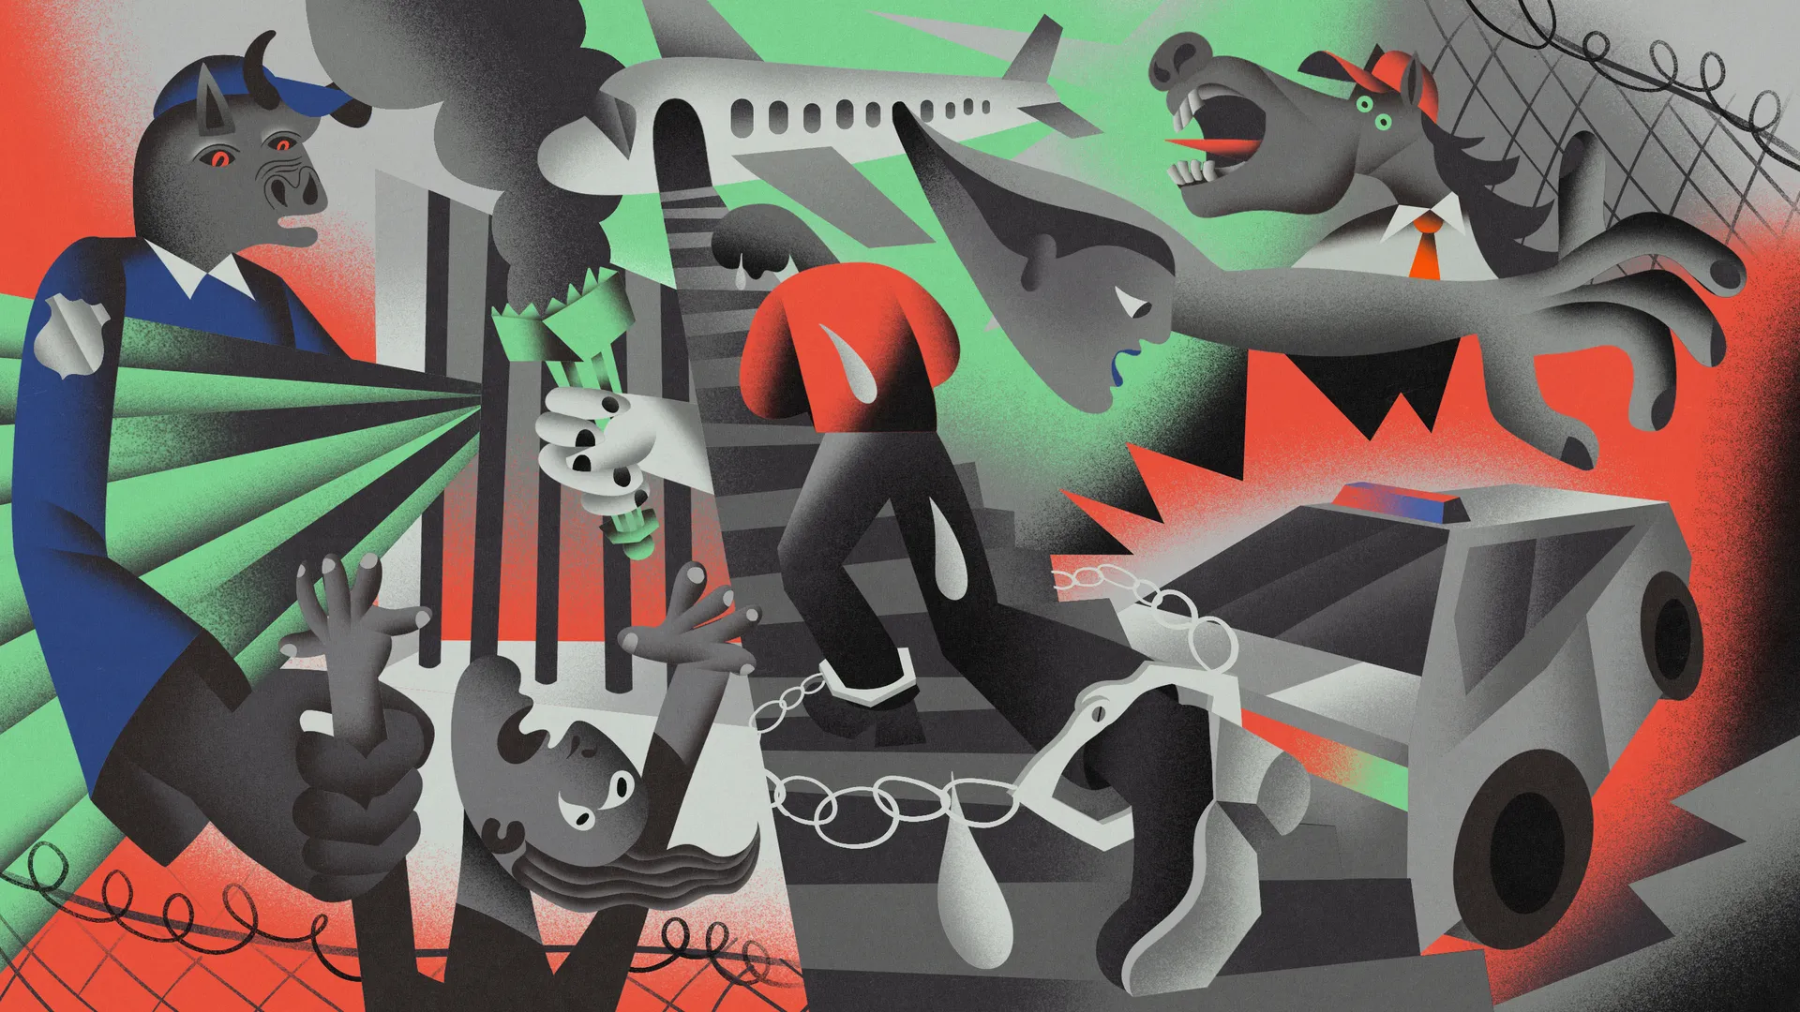

Obstacles to Trumps Project
- Strong federalism
- State governments control central aspects of education, law enforcement and civil society
- States can challenge federal laws in court
- 36% of Americans live in states, where legislature (creation of laws) and executive (carrying out of laws) are controlled by democrats
- Judges that fight back
- Judges have blocked 35 national orders from Trump (as of August 2025); Examples:
- Blocking the defunding of USAID (Agency of International Development)
- Upholding the right to birthright citizenship
- America is too diverse
- Many Americans still see the United States as a “Melting pod”; 82% believe that diversity makes America stronger
- 73% of Americans believe that freedom is very important to society
→ Makes it harder to take freedom away or justify fascist or racist policies
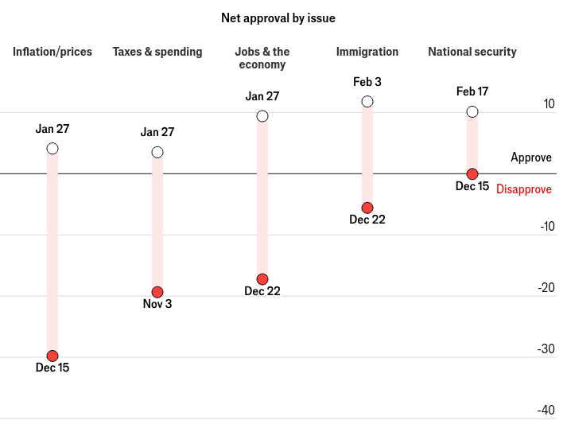
- Direct negative impact of bad policy
- Inflation and high prices after tariffs
- Cuts to healthcare subsidies
- Rising unemployment
→ This makes his voters unhappy and will significantly weaken the Republicans chances in the next elections
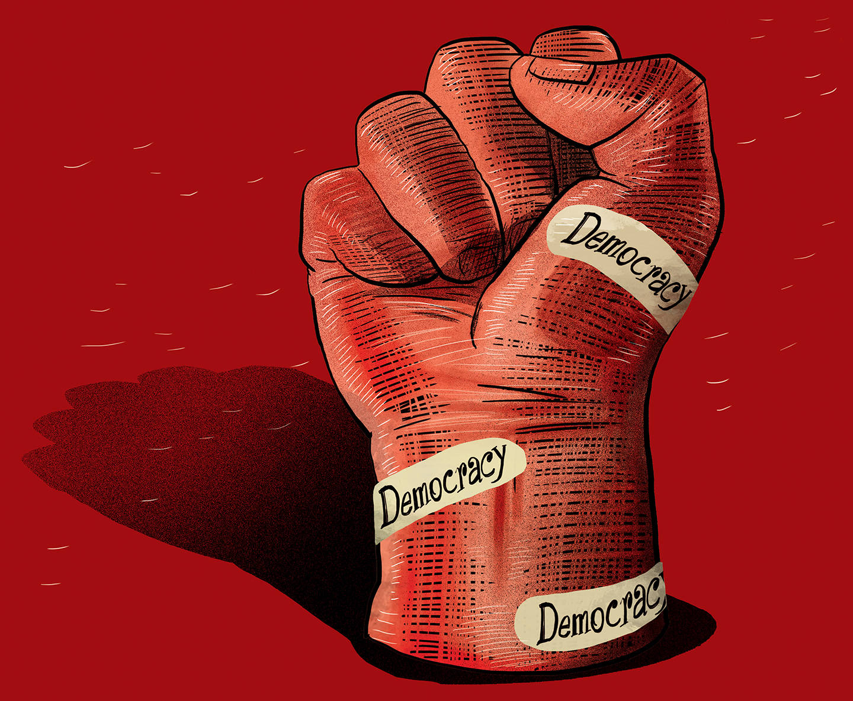

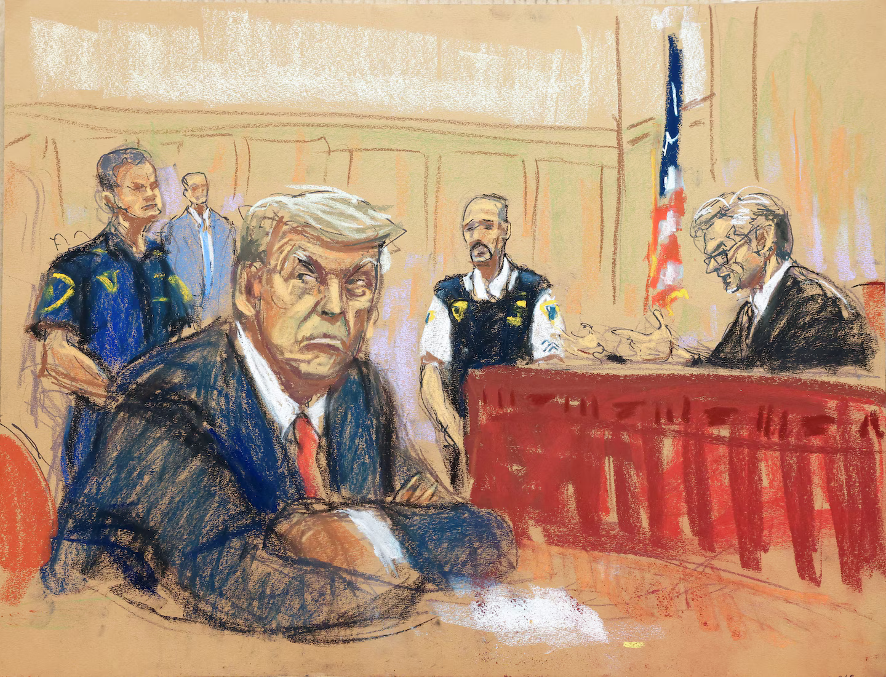



Sources

